nova MW6-How to set AP mode?
User Scenario:
If the customer runs a small company, and the area is about 400 square meters. He has AP Management router (Tenda G3) for the centralized management. He needs to set MW6 as AP mode to offer wireless network.

Solution:

1. Use mobile phone to download "Tenda WiFi" App;
2. Power on a node, connect WAN port with AP Management router by ethernet cable.
3. Use mobile phone to connect MW6 WiFi signal when LED blinks blue. (SSID and password can be found at the bottom of the node);
4. Open the App to finish configuration by following instructions. Picture will be showed as below:

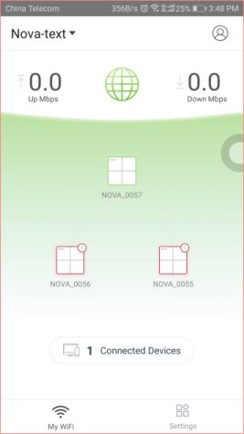

5. Tap "Settings" > "Internet Settings".
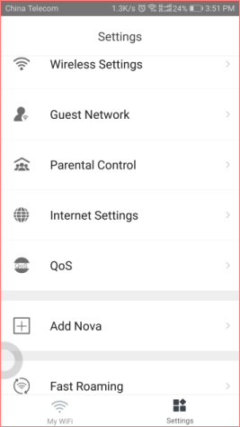

6. Select "Bridge" and tap "Save" on the upper right corner.
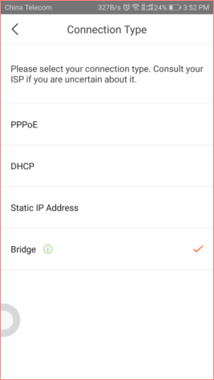
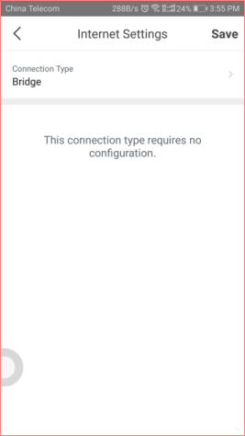

Note:
After the bridge mode is set, the App can still manage nova, but some advanced features cannot be used, such as Guest Network, Port Forwarding, UPnP, DNS, DHCP Server and etc.

7. Then power on the other two nodes, startup completes when LED blinks blue. Mesh network is established when LED turns to solid blue.

8. You can place them where you want.

